POINTS TO BE TAKEN CARE IN WEBSITE WORK
- Manufacturing address to be changed to

Yatee Steel Structures Pvt Ltd,
Nandasan, Kadi, Near Ahmedabad Mehsana Highway,
Gujarat – 382705

- Things to change in about us section
- Who are we

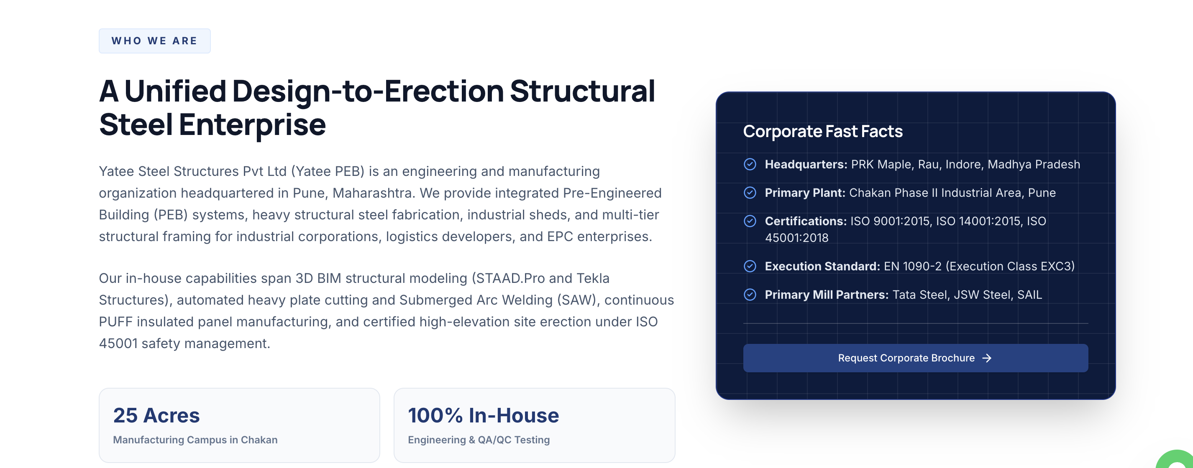

Yatee Steel Structures Pvt Ltd (Yatee PEB) is an engineering service provider and manufacturing organization headquartered in Indore, Madhya Pradesh. With having branches in Siliguri, (W.B.), Patna (Bihar).

We provide integrated Pre-Engineered Building (PEB) systems, heavy structural steel fabrication, industrial sheds, and multi-tier structural framing and sheeting systems for industrial corporations, logistics developers, and EPC enterprises.

Our in-house capabilities span 3D BIM structural modeling (STAAD.Pro and Tekla Structures), automated heavy plate cutting and Submerged Arc Welding (SAW), Automatic H Beam line (PTW) machine in our manufacturing unit.

Corporate Fast Facts
- Headquarters: PRK Maple, Rau, Indore, Madhya Pradesh ( mark full address with pin code)
- Primary Plant: Chakan Phase II Industrial Area, Pune ( change the address with mentioned above for plant address as Nandasan, kadi, Near Ahmedabad Mehsana Highway, Gujarat - 382705
- Certifications: ISO 9001:2015
- Execution Standard: EN 1090-2 (Execution Class EXC3)
- Primary Mill Partners: Tata Steel, JSW Steel, SAIL

The plant premises area is about – 6 acres

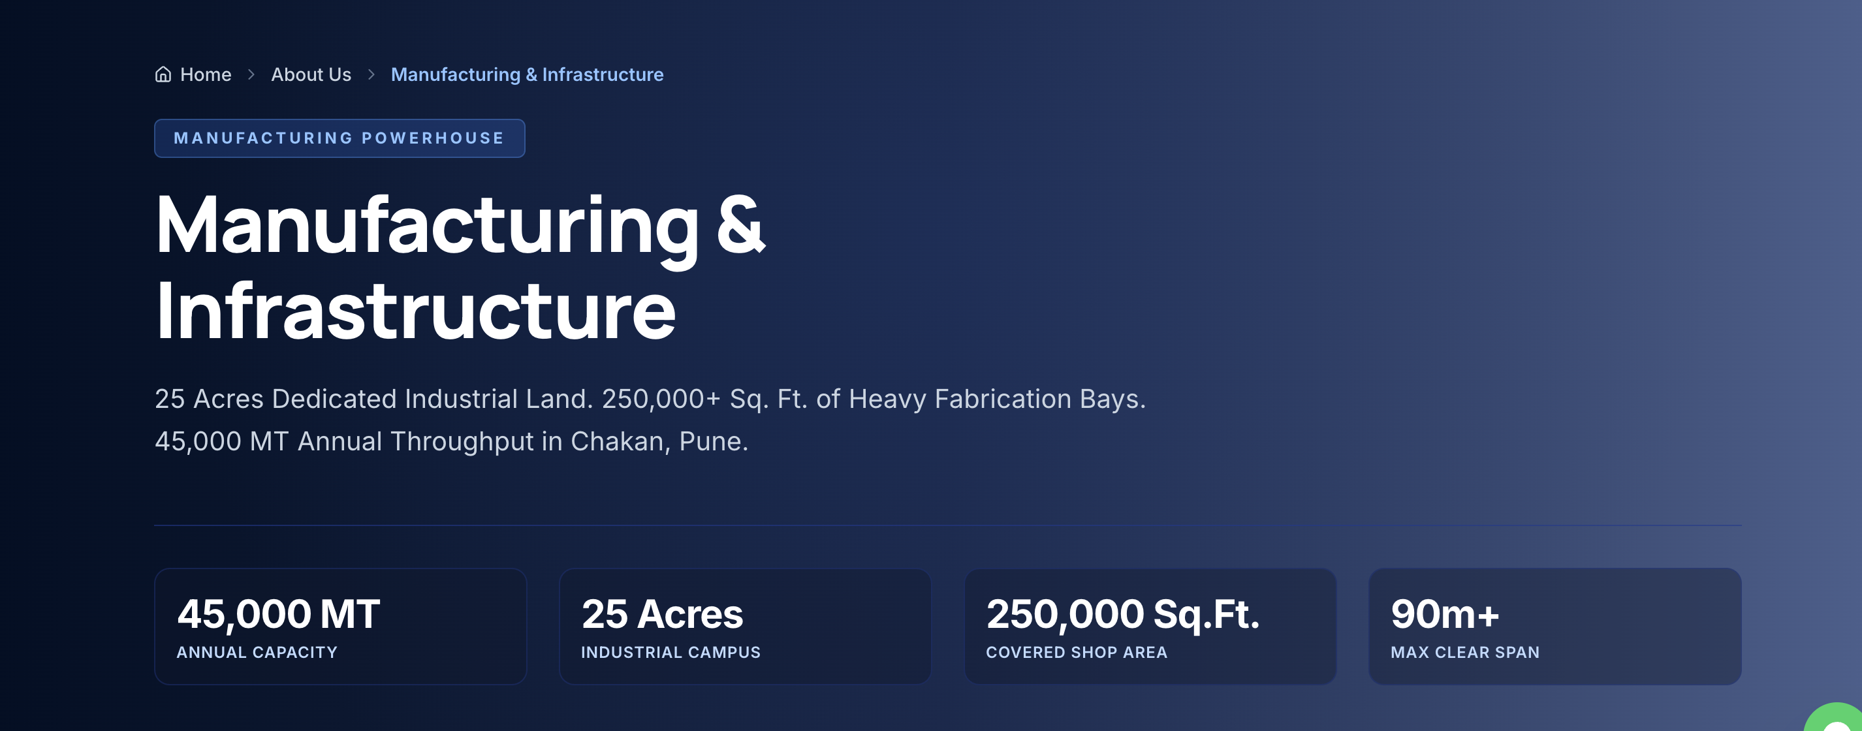
- under THIS SECTION CHANGE PLANT AREA TO 6 ACRES
- Annual capacity to be mentioned 22000 MT
- From machine section puff panel press to be removed instead of that you can mention CNC Plasma cutting machine for smooth and precise plate cutting.

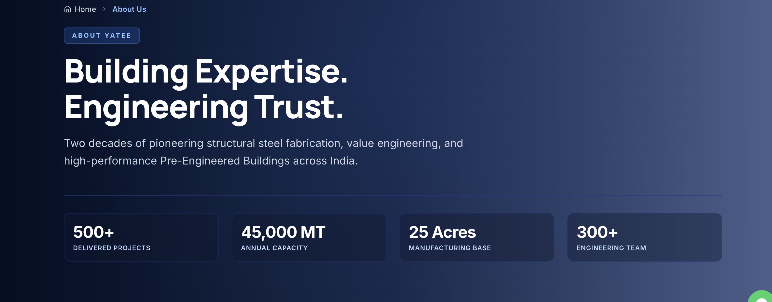
- Under this section in delivered project show 100 plus
- Annual capacity to be mentioned 22000 MT
- Plant area to be mentioned as 6 acres
- And engineering team to be mentioned as 20 +

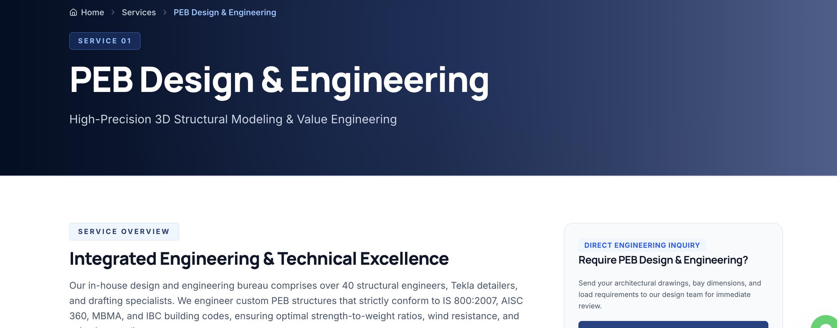

- In this section of services in house team have more than 10 professional from core engineering background to cater the technical requirements of our client lead by experienced leadership of more than 15 years in pre engineered building fraternity.

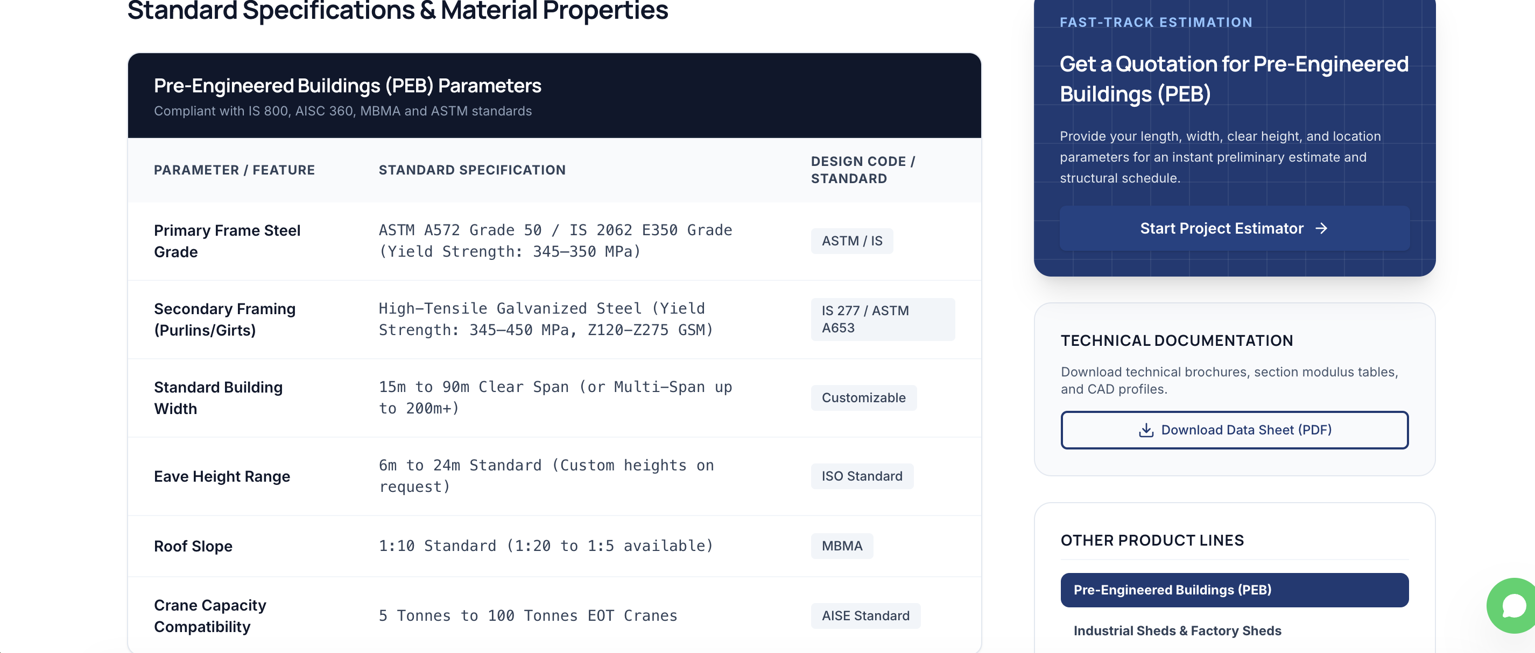

- Under this section change the fonts of things mentioned below standard specifications
- Under product tab these fonts need to be changed in all entities. Rest seems fine as of now and can be modified further

- WE NEED TO DISCUSS PROJECTS, NEWS AND CONTACT PAGE JOINTLY

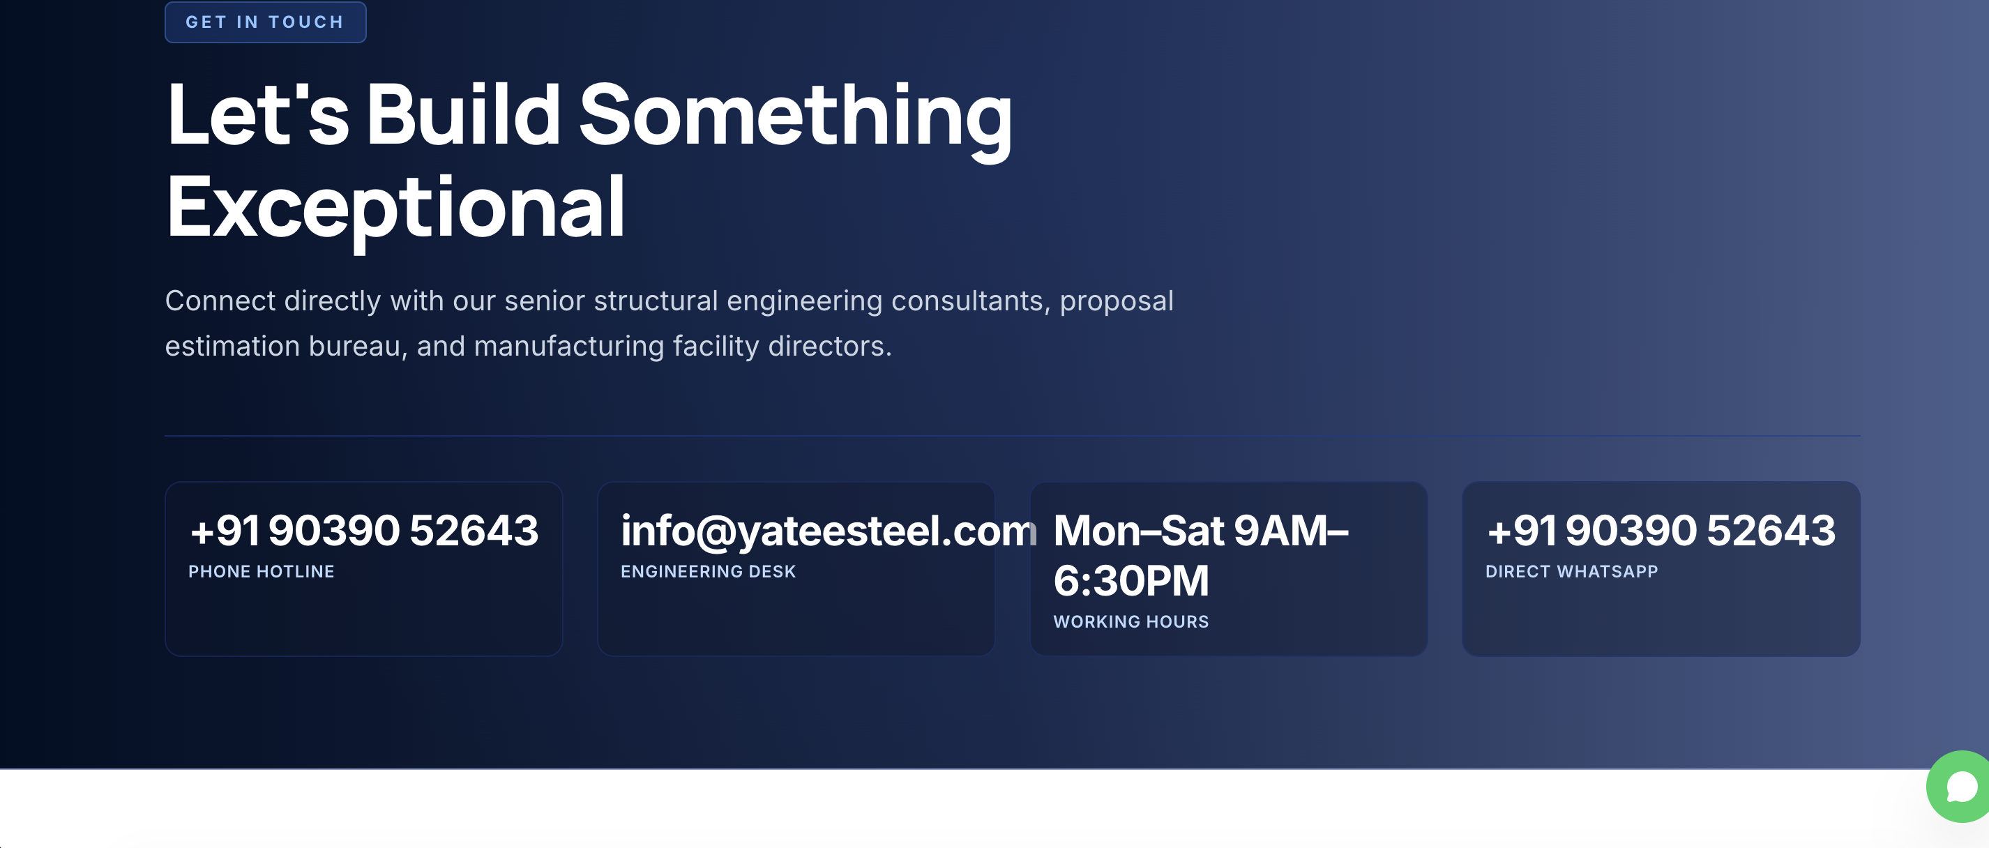
- This needs to be aligned in ratio with page.

- ISO 9001:2015 NEEDS TO BE MENTIONED

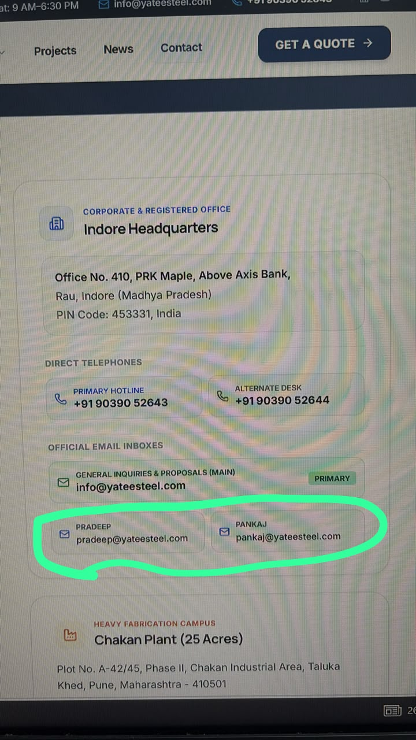

Remove Pankaj and Pradeep email id and mobile number, only show info mail id and landline phone number 0731-4933570 of company.
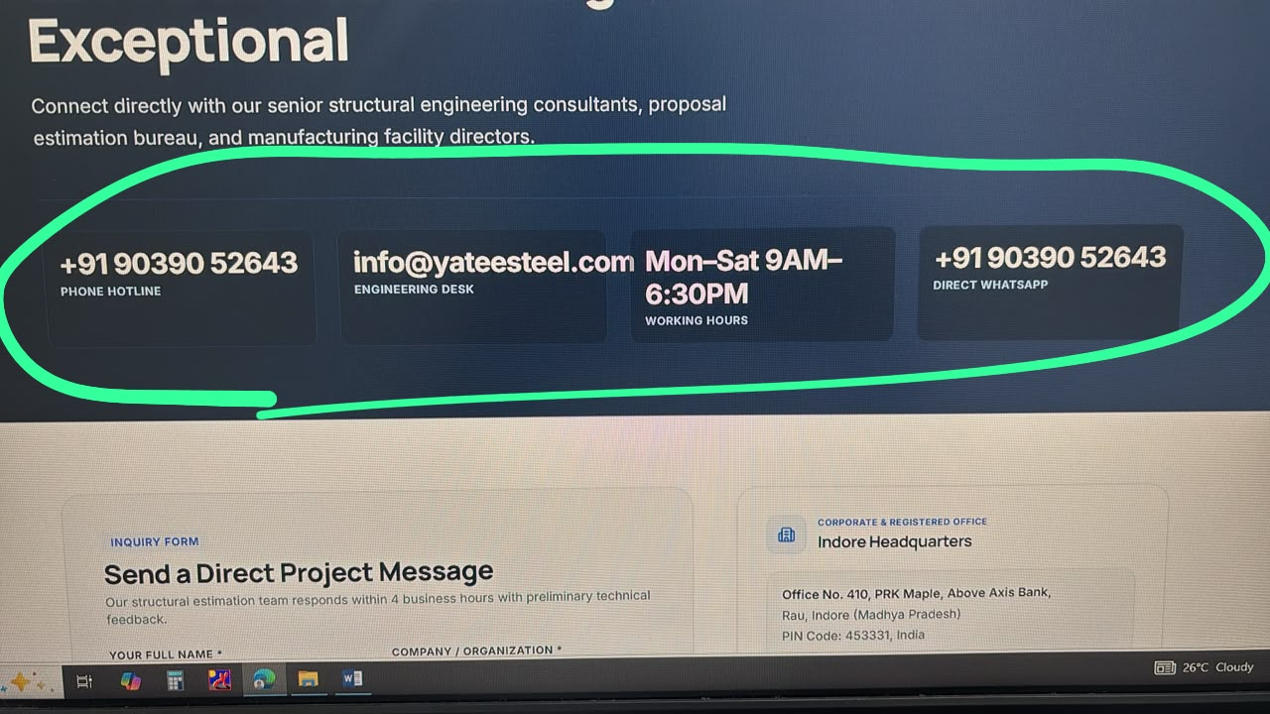
Manage font sizes.
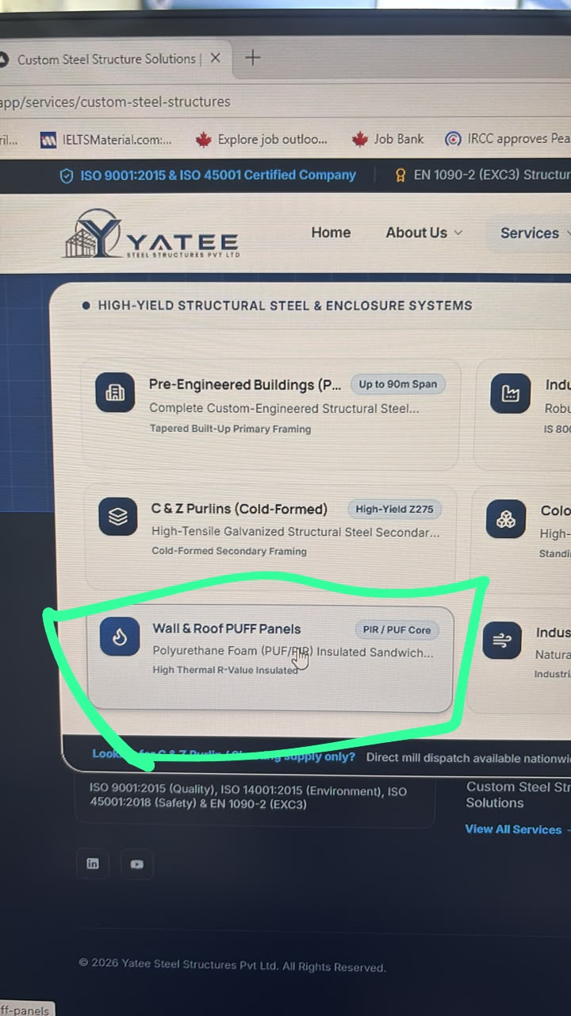

Instead of wall and roof puff panels. Kindly add LGS structure

